Soldering Tutorial

Remember that when soldering, the rosin in the solder releases fumes. These fumes are harmful to your eyes and lungs. Therefore, always work in a well ventilated area. Hot solder is also dangerous. Be sure not to let is splash around because it will burn you almost instantly. Eye protection is also advised.

Step 1: Equipment:
Soldering requires two main things: a soldering iron and solder. Soldering irons are the heat source used to melt solder. Irons of the 15W to 30W range are good for most electronics/printed circuit board work. Anything higher in wattage and you risk damaging either the component or the board. Note that you should not use so-called soldering guns. These are very high wattage and generate most of their heat by passing an electrical current through a wire. Because of this, the wire carries a stray voltage that could damage circuits and components. The choice of solder is also important. One of the things to remember is to never use acid core solder. Acid core solder will corrode component leads, board traces and form conductive paths between components. The best solder for electronics work is a thin rosin core solder. I prefer a thickness of 0.75mm (.033”), but other thicknesses will also work. Just remember not to get anything too thick.
Step 2: Surface Prep:
Strong, low resistance joints come from cleaning the surface. All surfaces to be soldered should be cleaned with steel wool and solvent. Lacquer thinner works well. Some people like to use sand paper but steel wool is usually safer
Step 3: Component Placement:
Place the component on the board by bending the leads as necessary and inserting the component through the proper holes on the board. It is a good idea to bend the leads on the bottom of the board at a 45 degree angle.
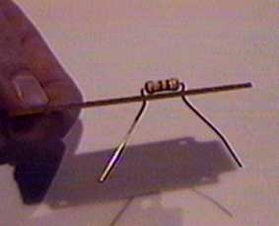
Step 4: Apply Heat:
Apply a very small amount of solder to the tip of the iron. This helps conduct the heat to the component and board, but is not the solder that will bond the joint. Now you are ready to heat the component and board. Lay the iron tip so that it rests against both the component lead and the board. Normally, it takes one or two seconds to heat up the component enough to solder.
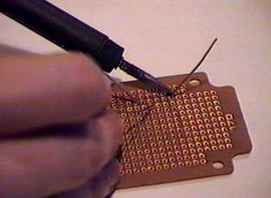
Step 5: Apply Solder And Remove Heat:
Once the component lead and solder pad has heated up, you are ready to apply solder. Touch the tip of the strand of solder to the component lead and solder pad, but not the tip of the iron. If everything is hot enough, the solder should flow freely around the lead and pad. Once the surface of the pad is completely coated, you can stop adding solder and remove the soldering iron (in that order). Do not move the joint for a few seconds to allow the solder to cool. If you do move the joint, you will get what is called a "cold joint". 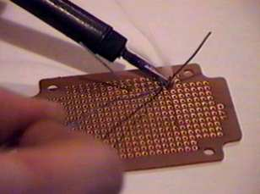
Step 6: Cleanup
Clip the excess wire after each piece has been installed. After you have made all the solder joints, you may wish to clean with steel wool or solvent to remove all the left over rosin. You may also wish to coat the bottom of the board with laquer. This will prevent oxidation and keep it nice and shiny.
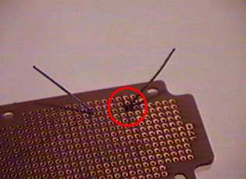

Tips and Tricks:
- Heatsinks. Heatsinks are necessary for the leads of sensitive components such as ICs and transistors. If you do not have a clip on heatsink, then a pair of pliers is a good substitute.
- Keep tip clean. A clean iron tip means better heat conduction and a better joint. Use a wet sponge to clean the tip between joints.
- Joints. It is a good idea to check all solder joints with an ohmmeter after they are cooled. If the joint measures any more than a few tenths of an ohm, then it may be a good idea to resolder it.
- Proper iron. Remember that bigger joints will take longer to heat up with an 30W iron than with a 150W iron. While 30W is good for printed circuit boards and the like, higher wattages are great when soldering to a heavy metal chassis.
- Small parts first. Solder resistors, jumper leads, diodes and any other small parts before you solder larger parts like capacitors and transistors. This makes assembly much easier.

Summary:
- All parts must be clean and free from dirt and grease.
- Try to secure the work firmly.
- "Tin" the iron tip with a small amount of solder. Do this immediately, with new tips being used for the first time.
- Clean the tip of the hot soldering iron on a damp sponge.
- Many people then add a tiny amount of fresh solder to the cleansed tip.
- Heat all parts of the joint with the iron for under a second or so.
- Continue heating, then apply sufficient solder only, to form an adequate joint.
- Remove and return the iron safely to its stand.
- It only takes two or three seconds at most, to solder the average p.c.b. joint.
- Do not move parts until the solder has cooled.

Troubleshooting Guide:
- Solder won't "take" - grease or dirt present - desolder and clean up the parts. Or, material may not be suitable for soldering with lead/tin solder (eg aluminium).
- Joint is crystalline or grainy-looking - has been moved before being allowed to cool, or joint was not heated adequately - too small an iron/ too large a joint.
- Solder joint forms a "spike" - probably overheated, burning away the flux.

